The Marr-Hildreth Edge Detector
Code:
import cv2
import numpy as np
import matplotlib.pyplot as plt
image = cv2.imread('tol.jpg', cv2.IMREAD_GRAYSCALE)
blurred = cv2.GaussianBlur(image, (5, 5), 1.0)
laplacian = cv2.Laplacian(blurred, cv2.CV_64F)
marr_hildreth = np.uint8(np.absolute(laplacian))
plt.figure(figsize=(12, 6))
plt.subplot(1, 2, 1)
plt.title("Original Image")
plt.imshow(image, cmap='gray')
plt.axis('off')
plt.subplot(1, 2, 2)
plt.title("Marr-Hildreth Edge Detection")
plt.imshow(marr_hildreth, cmap='gray')
plt.axis('off')
plt.show()
cv2.imwrite('marr_hildreth_tol.jpg', marr_hildreth)
Code Explanation
- Image Preprocessing:
  - The image is read in grayscale mode for simpler intensity-based operations.
  - A Gaussian blur is applied to smooth the image and reduce noise, an essential step for Marr-Hildreth edge detection.
- Laplacian Operator:
  - The Laplacian operator computes the second derivative of the image, detecting regions where intensity changes rapidly (edges).
  - The Gaussian-smoothed image ensures that noise does not lead to spurious edge detection.
- Edge Magnitude:
  - The absolute value of the Laplacian is taken to capture both positive and negative edge responses.
  - The result is converted to an 8-bit unsigned integer for proper visualization.
- Visualization:
  - Displays the original and edge-detected images side by side.
  - Saves the final edge-detected image as marr_hildreth_tol.jpg.
Output:

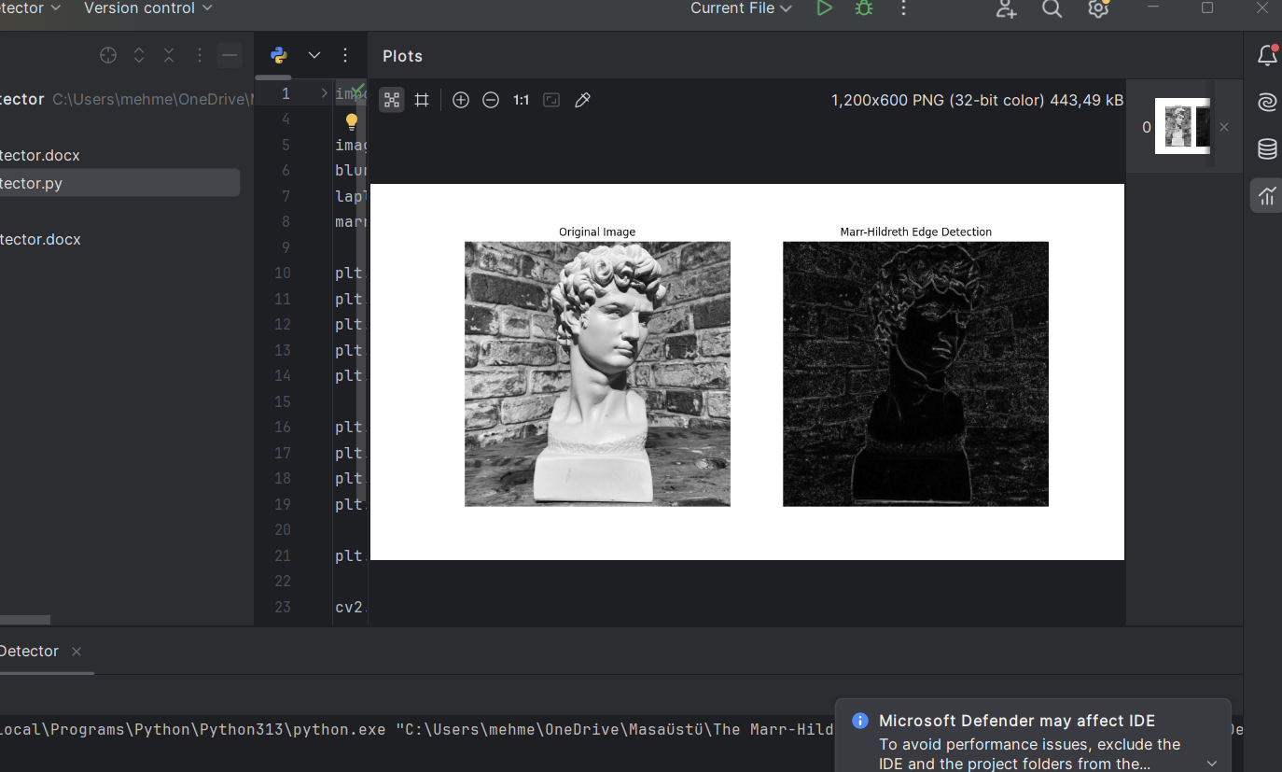

Report
Objective
To detect edges in the image tol.jpg using the Marr-Hildreth edge detection technique, which combines Gaussian smoothing with the Laplacian operator.
Process
- Gaussian Smoothing:
  - Reduces noise and small variations in intensity that could interfere with edge detection.
  - Ensures edges are identified at a meaningful scale by applying a Gaussian blur.
- Laplacian Edge Detection:
  - The Laplacian operator identifies regions of rapid intensity change by calculating the second derivative.
  - Both positive and negative zero-crossings are considered as edges.
- Output Image:
  - The absolute values of the Laplacian are used for edge visualization.
  - The result highlights prominent edges while suppressing noise and minor details.
Results
- The Marr-Hildreth method effectively detected edges in the image.
- Noise was significantly reduced due to Gaussian smoothing.
- Prominent edges, such as object boundaries, were highlighted, while finer textures were suppressed.
Conclusion
The Marr-Hildreth edge detector is effective for edge detection in images like tol.jpg, particularly when noise reduction is critical. However, it may smooth out fine details, making it less suitable for applications requiring high-detail preservation.
Recommendations
- Adjust the Gaussian kernel size and variance for different scales of edge detection.
- Use other edge detectors (e.g., Canny) for applications requiring sharper edge definition.

